# AST 325-326 Spectra Observations

Michael Williams 2022

## Getting to the observatory

The spectra observing sessions will be held on the 15th floor balcony of the McLennan Physical Laboratories (Burton Tower) at 60 St George St. Take the elevators to the 14th floor. Turn right and go to the end of the hall. Turn right again and go halfway down the hall. The stairs up to the 15th floor are on the right (halfway down the hall).

At the 15th floor go out on to the balcony (the door to the balcony is straight a head when you get to the 15th floor. There will likely also be AST 101 students there. The telescope is located on the Southeast corner of the balcony. Turn left once you are on the balcony go past the green lights marking the end of the space for AST 101. You should see the telescope.

If you need to contact the telescope operator:

Michael Williams

Email: [williams@astro.utoronto.ca](mailto:williams@astro.utoronto.ca)

Cell Phone: 416-629-0973

## The Telescope and Spectrograph

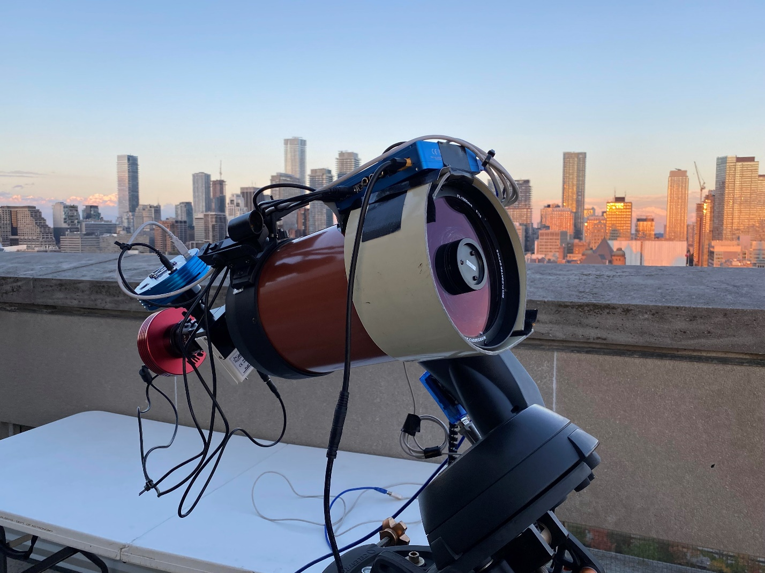

The telescope is a Celestron Nextar 6se (<https://s3.amazonaws.com/celestron-site-support-files/support_files/1152120348_1106811069manua.pdf> ). The telescope has a f/6.3 focal reducer, which changes the total focal ratio from f/10 to f/6.3. This id done to better match the telescopes focal ratio to the spectrograph’s input focal ratio of f/4.

The spectrograph is a Skelyak Alpy Spectrograph (<https://www.shelyak.com/wp-content/uploads/DC0016B_Doc_Alpy_600_EN-1.pdf> ). The spectrograph has an resolution power ( R ) of 600. The spectra cover the entire visible wavelength range.

There are two CCD cameras on on the spectrograph. The first is an ATIK ???? (Camera 1 in the Camera software and the red camera in the above image). This camera images the spectra produced. The second camera is an ATIK ???? (Camera 2 in the camera software and the blue camera in the above image). This camera images the mirrored slit element in the spectrograph. It allows us to see what the telescope is pointed at as well as the position of the slit. We will use this camera to line up our objects with the spectrograph’s slit. This camera is often referred to as the Guide Camera.

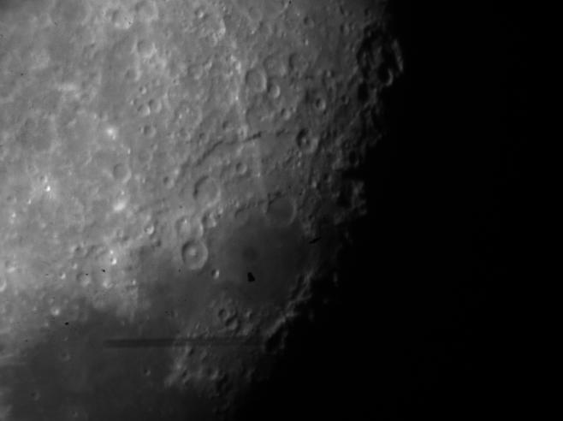

Above is an image of the Moon taken with the Guide Camera. A red line has been added to the image to mark the position of the slit.